**Top** [**10 hackers**](https://www.quora.com/Who-are-the-top-10-hackers?no_redirect=1)

1. **Kevin Mitnick**



Kevin Mitnick, once considered the most-wanted cybercriminal in the United States, is often touted as the poster child of computer hacking.In 1981, he was charged with stealing computer manuals from Pacific Bell. In 1982, he hacked the North American Defense Command (NORAD), an achievement that inspired the 1983 film WAR GAMES.

1. **Robert Tappan Morris**



On November 2, 1988, Robert Morris released a worm that brought down one-tenth of the Internet.. Morris said it was just a stunt and added that he truly regretted wreaking $15 million worth of damage, the estimated amount of carnage caused by his worm.

1. **Adrian Lamo:**

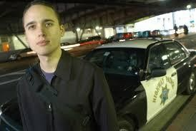

In 2001, 20-year-old Adrian Lamo used an unprotected content management tool at Yahoo to modify a Reuters article and add a fake quote attributed to former Attorney General John Ashcroft. He was aka "The Homeless Hacker" because he preferred to wander the streets with little more than a backpack and often had no fixed address.

1. **Vladimir Levin**



Seeming like the opening of a James Bond movie, Vladimir Levin was working on his laptop in 1994 from his St. Petersburg, Russia, apartment. He transferred $10 million from Citibank clients to his own accounts around the world.

vin's career as a hacker was short lived -- with a capture, imprisonment, and recovery of all but $400,000 of the original $10 million.

1. **Guzman Onel**

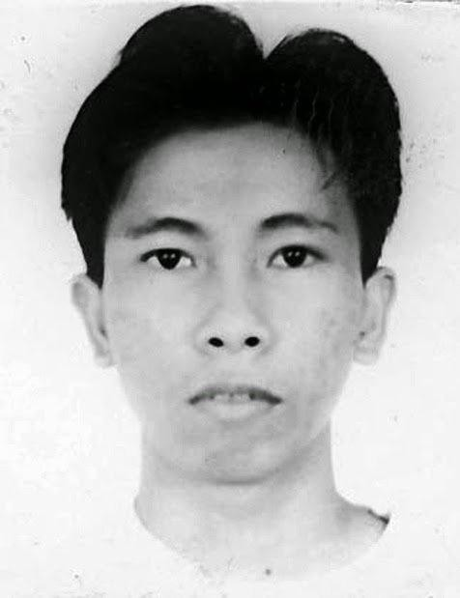

If you have ever feared viruses that were sent in the form of an email, this hacker has certainly contributed to this. Guzman created the virus "I love you", which was sent in the form of a file called "love-the-letter-for-you".

Once the victim opened the attachment, the email was sent to the friends on their list. Hacker damage from malware totaled $ 8.7 billion.

1. **Raphael Gray**

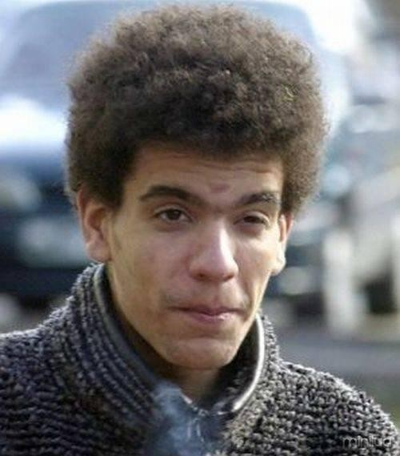

Gray was convicted of stealing 23,000 credit card numbers on the Internet, including one from Bill Gates. He was captured by the FBI in 1999.

1. **Albert Gonzalez**

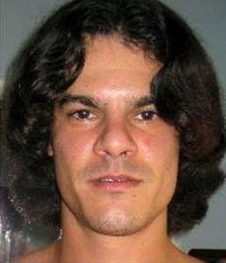

At 22, Gonzalez was arrested in New York for debit card fraud related to stealing data from millions of card accounts. To avoid jail time, he became an informant for the Secret Service, ultimately helping indict dozens of Shadowcrew members.

Gonzalez stole more than 180 million payment card accounts from companies including OfficeMax, Dave and Buster's and Boston Market.

1. **Jeanson James Ancheta**



Jeanson James Ancheta had no interest in hacking systems for credit card data or crashing networks to deliver social justice. Instead, Ancheta was curious about the use of bots—software-based robots that can infect and ultimately control computer systems

he was able to compromise more than 400,000 computers in 2005.

1. **Kevin Poulsen :**

In 1983, a 17-year-old Poulsen, using the alias Dark Dante, hacked into ARPANET, the Pentagon’s computer network. Although he was quickly caught, the government decided not to prosecute Poulsen, who was a minor at the time. Instead, he was let off with a warning.

In 1988, Poulsen hacked a federal computer and dug into files pertaining to the deposed president of the Philippines, Ferdinand Marcos.

in 1990, he hacked a radio station contest and ensured that he was the 102nd caller, winning a brand new Porsche, a vacation, and $20,000.

He has since converted to white hat hacking and journalism, writing about cyber security and web-related socio-political causes for Wired, The Daily Beast and his own blog.

1. **George Hotz**

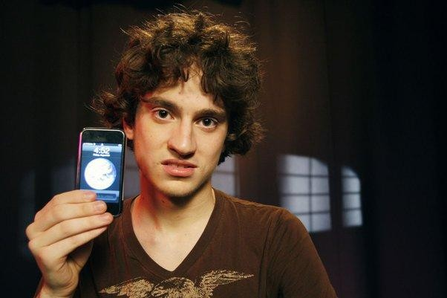

While George Hotz may be a renowned jailbreak artist, he's best known for being named as the primary reason for the April 2011 PlayStation breach. As one of the first hackers to jailbreak the Sony PlayStation 3, Hotz found himself in the middle of a very mean, public, and messy court battle with Sony , the hacker group Anonymous attacked Sony in what has been the most costly security break of all time. Hotz denied any responsibility for the attack and said, "Running homebrew and exploring security on your devices is cool; hacking into someone else's server and stealing databases of user info is not cool."